ACTIVE VAULT
User Guide
Version 1.6.1 · Encrypted NAS File Vault for Windows
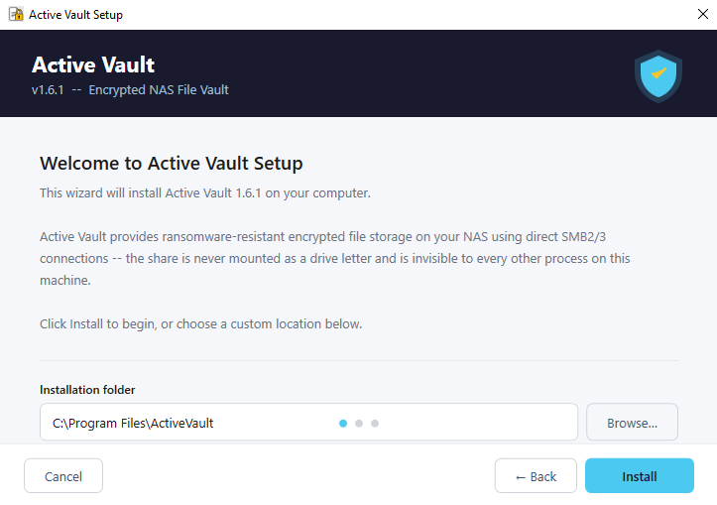

Copyright © 2026 VaultNX. All rights reserved.

1. Installation 3
2. License Activation 4
2.1 Enter Your License Key 4
3. Unlocking Your Vault 6
4. Vault Browser — File Operations 8
4.1 Creating a Folder 8
4.2 Adding Files 9
4.3 Downloading Files 10
4.4 Copying and Moving Files 10
4.5 Deleting Files 11
4.6 Locking the Vault 12
5. Sharing Files 12
5.1 ActiveVault Bundle (.avb) 13
5.2 Encrypted ZIP (.zip) 15
6. Settings 17
6.1 NAS Connection 17
6.2 Security 18
Recovery Key File 19
6.3 General 20
6.4 Audit Log 21
6.5 License 21
6.6 About 22
7. Troubleshooting 23
7.1 NAS Login Failure (STATUS_LOGON_FAILURE) 23
7.2 NAS Unreachable at Vault Unlock 24
7.3 Forgot Master Password 24
7.4 Share Export Errors 25

1. Installation
Run the Active Vault installer. The setup wizard opens automatically.

Figure 1 — Installation wizard
The wizard defaults to C:\Program Files\ActiveVault. Use Browse… to choose a custom location, then click Install to begin.

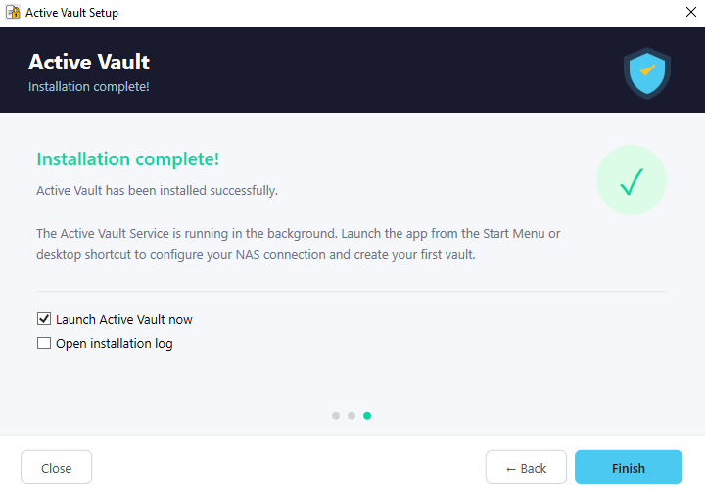
Figure 2 — Installation complete
When installation finishes, Installation complete! is displayed. The Active Vault background service starts automatically. Leave Launch Active Vault now ticked and click Finish to open the app.
ℹ The service starts with Windows and runs silently in the background. You do not need to relaunch it manually.

2. License Activation
The first time Active Vault opens, the setup wizard walks you through four steps: License → Connection → Vault → Security.

2.1 Enter Your License Key
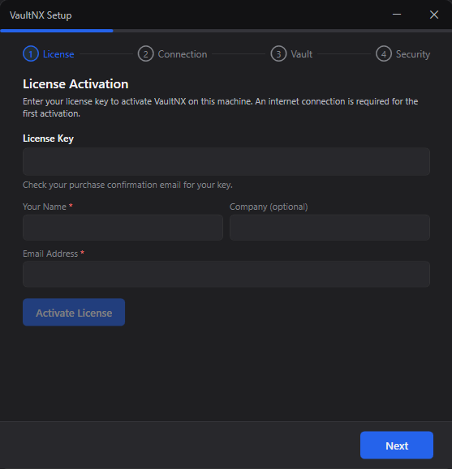
Figure 3 — License Activation screen
Fill in the following fields:
- License Key — found in your purchase confirmation email (format XXXXX-XXXXX)
- Your Name — required
- Company — optional
- Email Address — required; used for activation confirmation

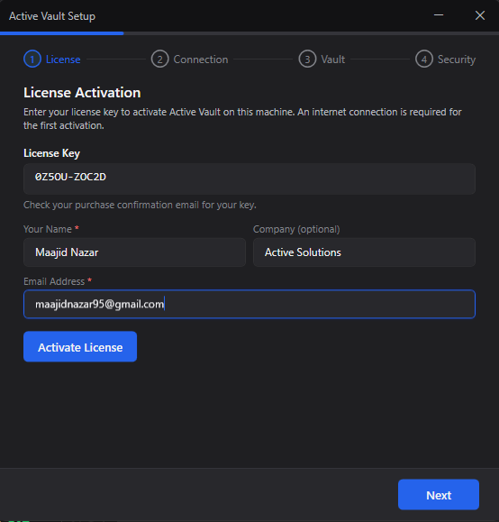
Figure 4 — License key and details entered
Click Activate License. An internet connection is required for the first activation. Once successful, click Next to proceed to the NAS connection step.

3. Unlocking Your Vault
After setup, every time you open Active Vault the vault browser opens in a Locked state. The vault folder is visible but its contents cannot be accessed until you unlock.

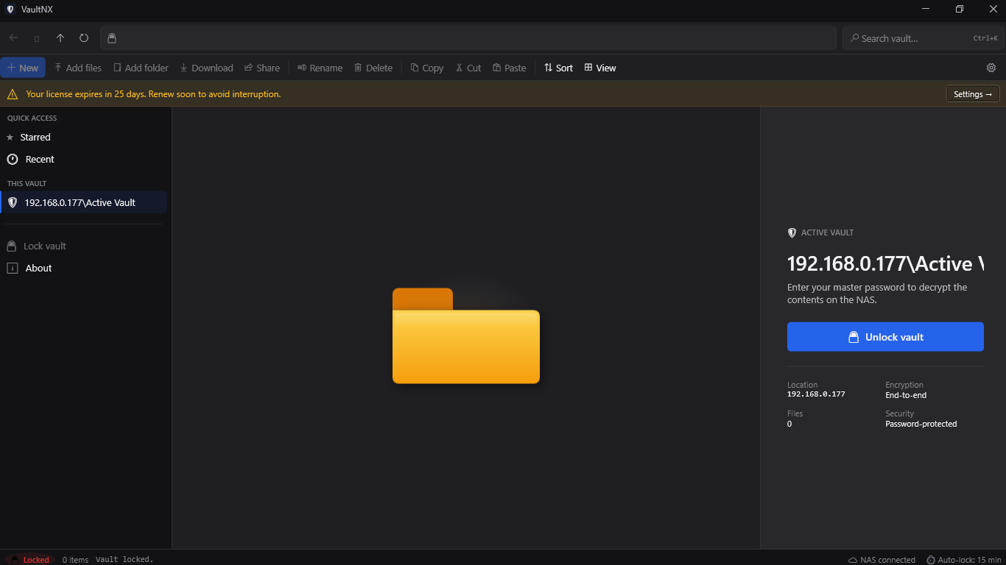
Figure 5 — Vault browser in locked state
The right-hand panel shows the vault name, NAS location, encryption type, and file count. Click Unlock vault to open the password prompt.

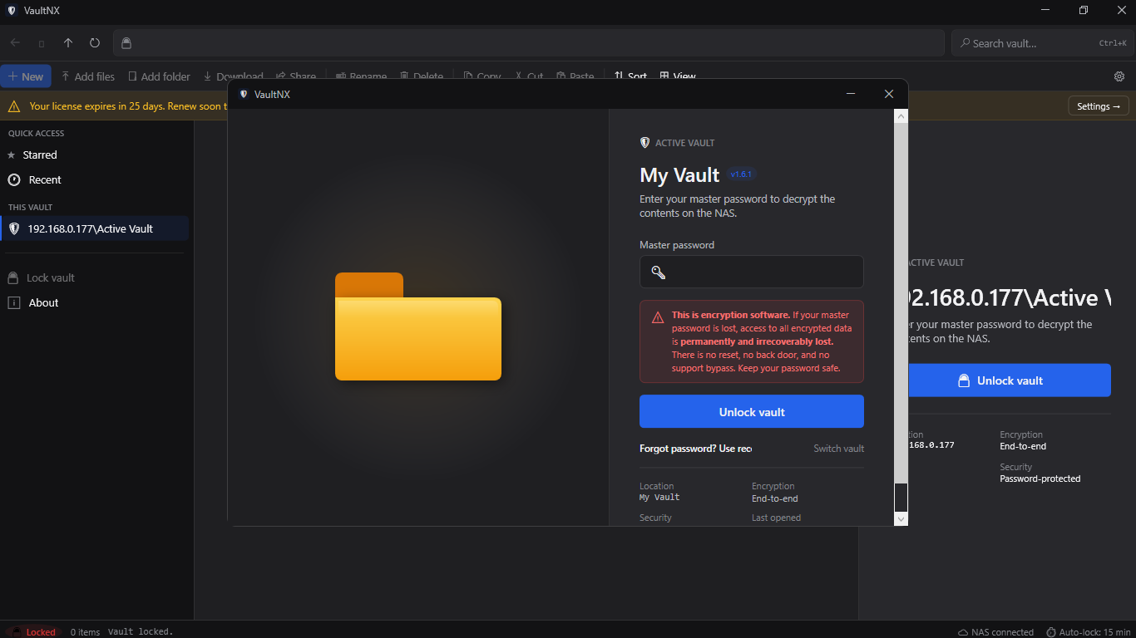
Figure 6 — Master password prompt
Enter your master password and click Unlock vault. The status bar changes from Locked (red) to Unlocked (blue) once the vault opens.

⚠ If your master password is lost, access to all encrypted data is permanently and irrecoverably lost. There is no reset, no back door, and no support bypass. Protect your password and generate a Recovery Key File — see Section 6.2.

4. Vault Browser — File Operations
When unlocked, the vault browser shows all encrypted files and folders on your NAS. Each entry displays its name, size, date modified, and an Encrypted status badge.

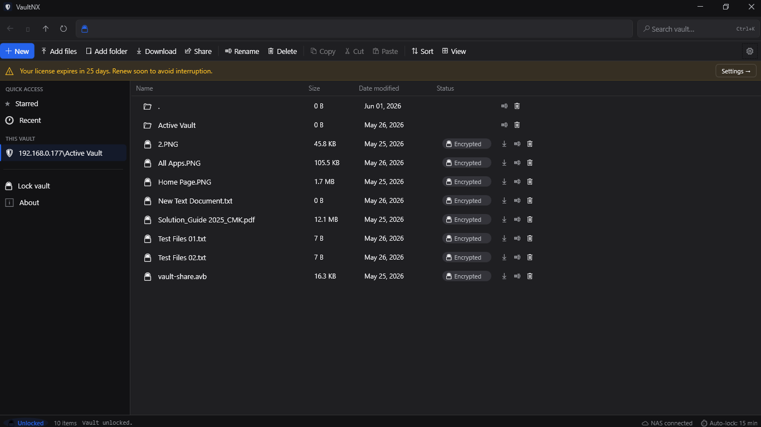
Figure 7 — Vault browser with files
The toolbar provides all file operations: Add files, Add folder, Download, Share, Rename, Delete, Copy, Cut, Paste, Sort, and View.

4.1 Creating a Folder
Click Add folder in the toolbar (or the + New menu). A dialog prompts for the folder name.
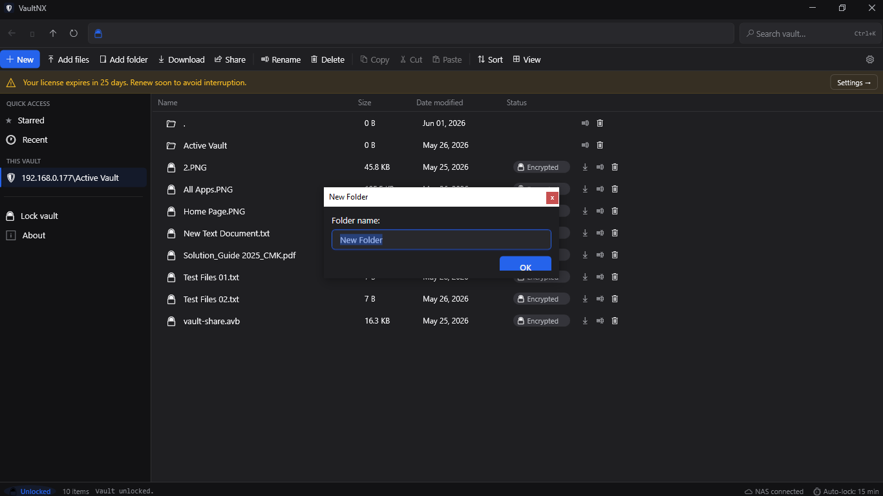
Figure 8 — New Folder dialog
Type the name and click OK. The folder is created directly inside the encrypted NAS share.

4.2 Adding Files
Click Add files to open the file picker.
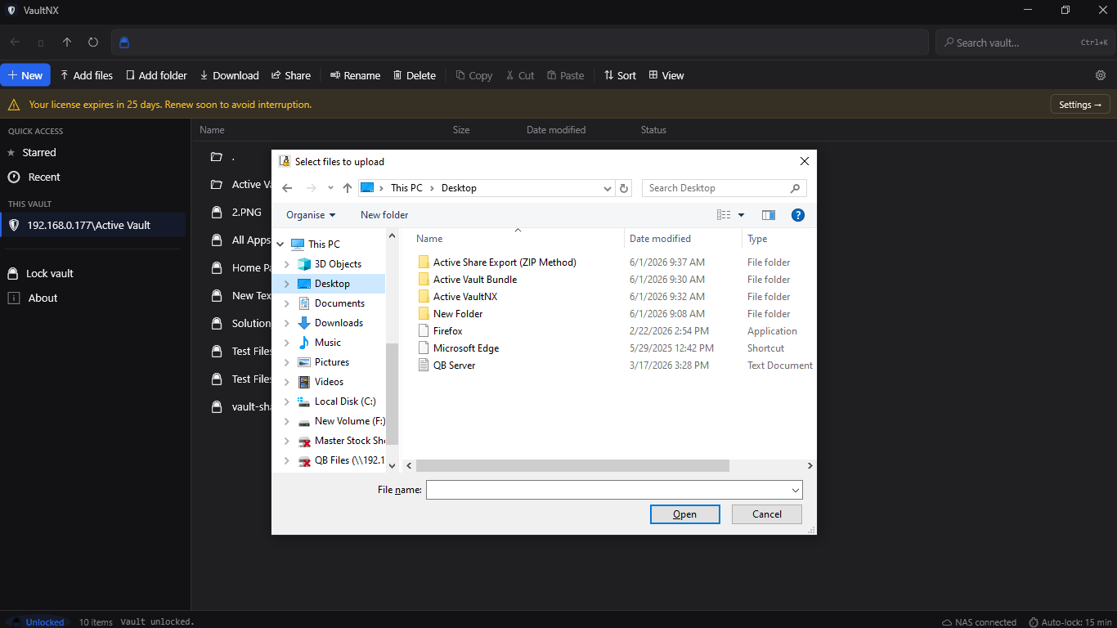
Figure 9 — File selection dialog
Browse to your files, select one or more, and click Open. Each file is encrypted on upload. The originals on your local PC are not modified.

4.3 Downloading Files
Select a file in the browser and click Download in the toolbar. The file is decrypted and saved to a location you choose on your local machine.

4.4 Copying and Moving Files
Copy: Select a file and click Copy. The status bar confirms “Copied: filename — navigate to destination and Paste”.
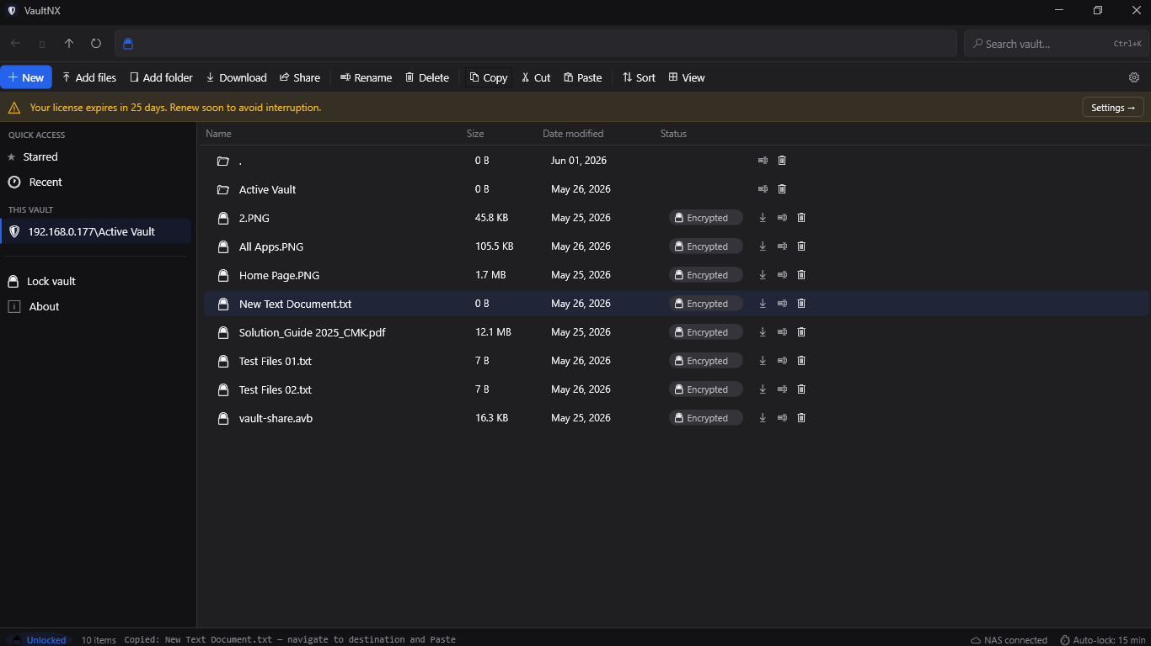
Figure 10 — Status bar confirming copy operation
Navigate to the destination folder and click Paste to complete the copy.

Move (Cut): Select a file and click Cut. The status bar confirms “Cut: filename — navigate to destination and Paste”.
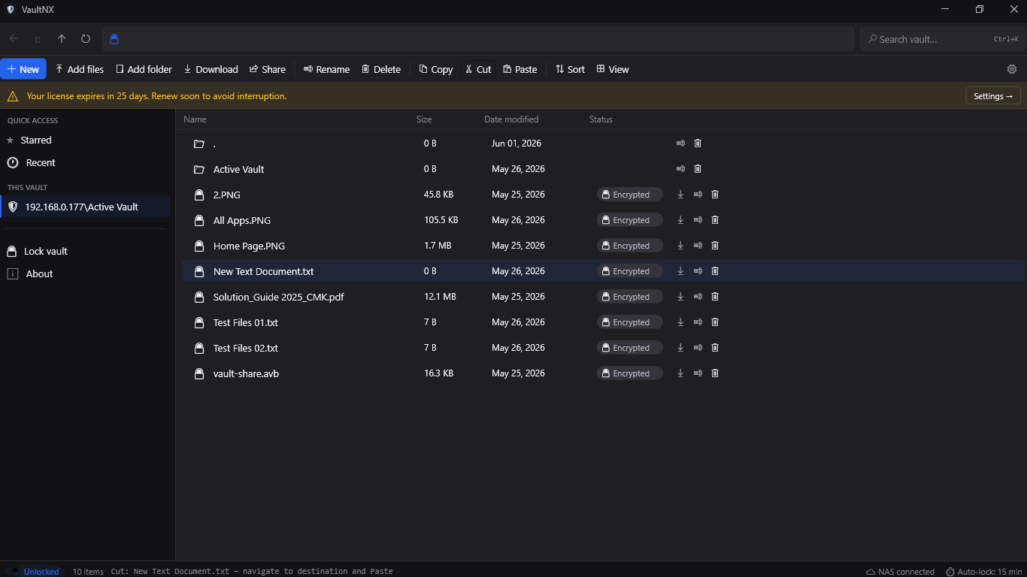
Figure 11 — Status bar confirming cut operation
Navigate to the destination folder and click Paste to move the file.

4.5 Deleting Files
Select a file and click Delete. A confirmation dialog warns that the action is permanent.
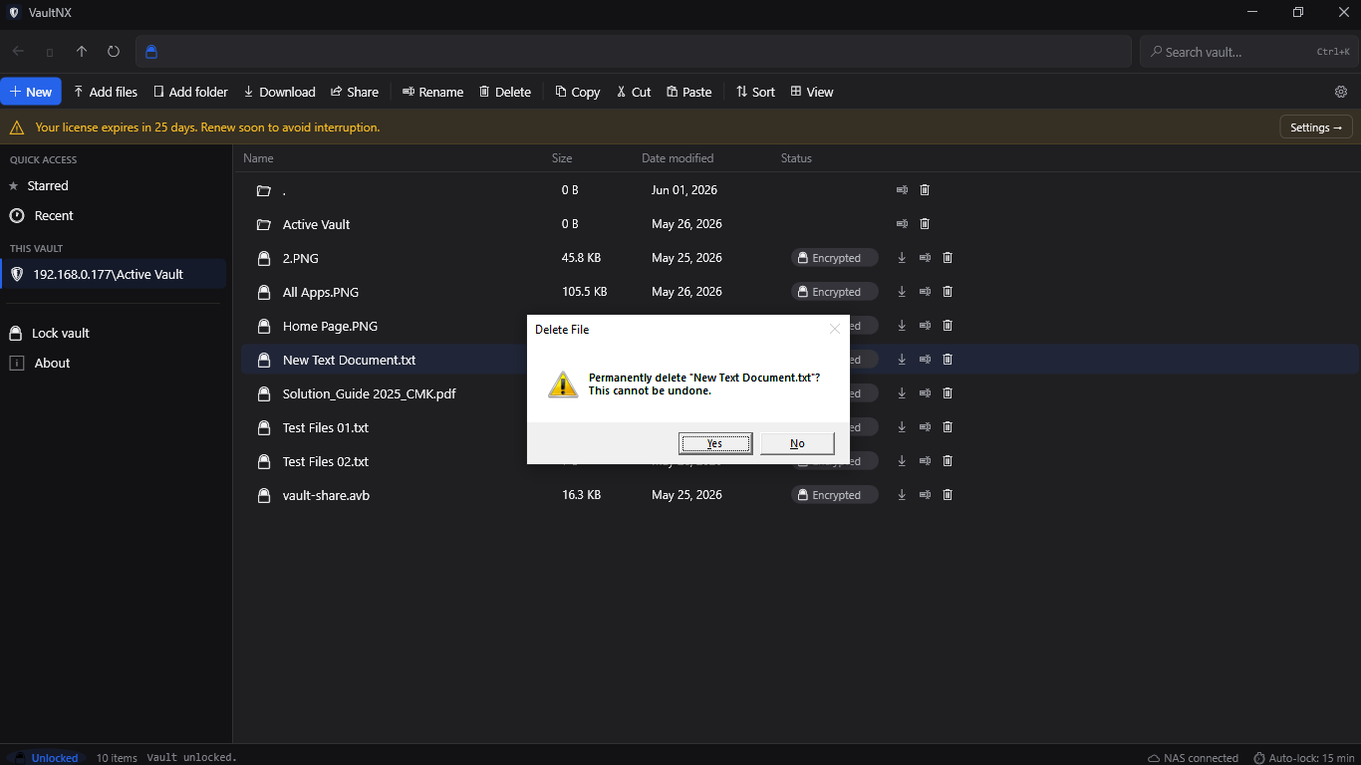
Figure 12 — Delete confirmation dialog
Click Yes to permanently delete the file, or No to cancel. Deleted files cannot be recovered.

4.6 Locking the Vault
Click Lock vault in the left sidebar at any time. The vault immediately returns to the locked state and all access to encrypted content is dropped.
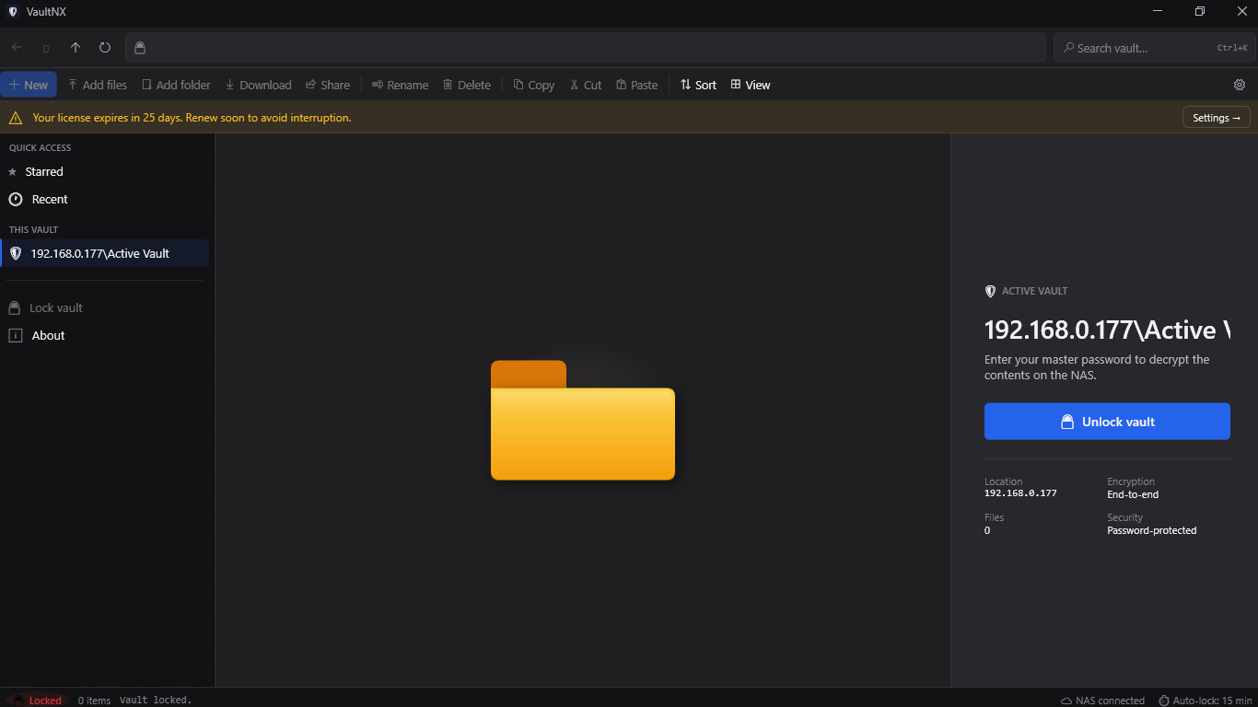
Figure 13 — Vault returned to locked state
The vault also locks automatically after the configured idle period. See Section 6.2 to adjust the auto-lock timer.

5. Sharing Files
Select one or more files in the vault browser and click Share in the toolbar. The Share Files dialog offers two export formats.
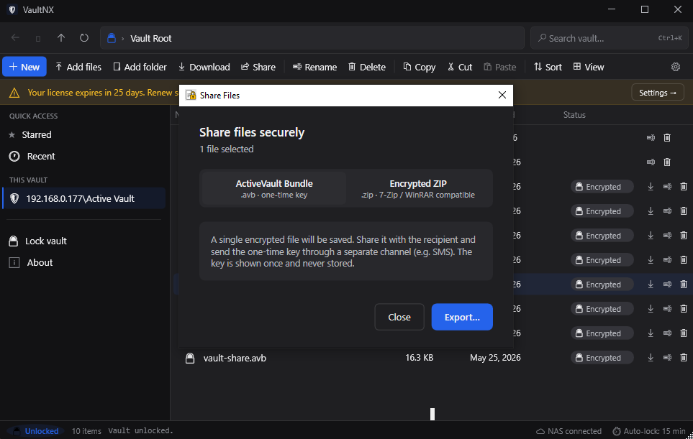
Figure 14 — Share Files dialog showing export options

5.1 ActiveVault Bundle (.avb)
An ActiveVault Bundle wraps the selected file in a single encrypted package protected by a randomly generated one-time key. The recipient must have Active Vault installed to open it.

To export as an ActiveVault Bundle:
- Select ActiveVault Bundle in the Share Files dialog and click Export…
- Choose a save location in the dialog that appears and click Save.

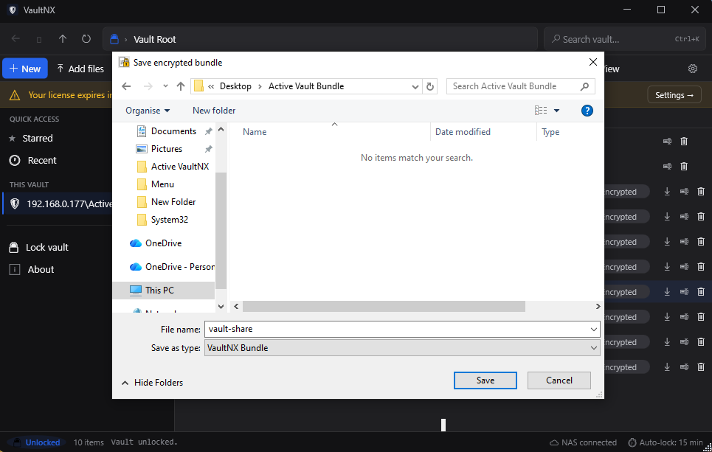
Figure 15 — Save encrypted bundle dialog

After saving, the one-time key is displayed on screen.
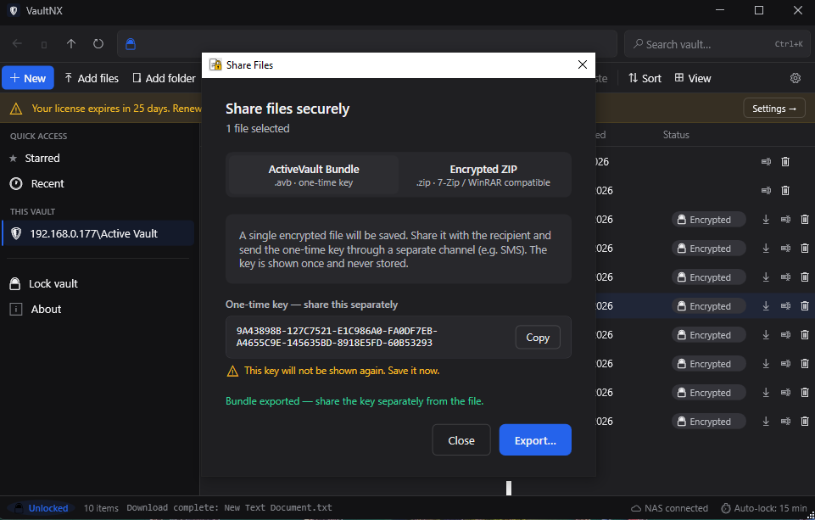
Figure 16 — One-time key displayed after export

⚠ This key is shown once and is never stored. Click Copy immediately and send it to the recipient through a separate channel — for example SMS or phone. Never send the key in the same email as the .avb file.

The saved .avb file appears in Windows Explorer as an AVB File.
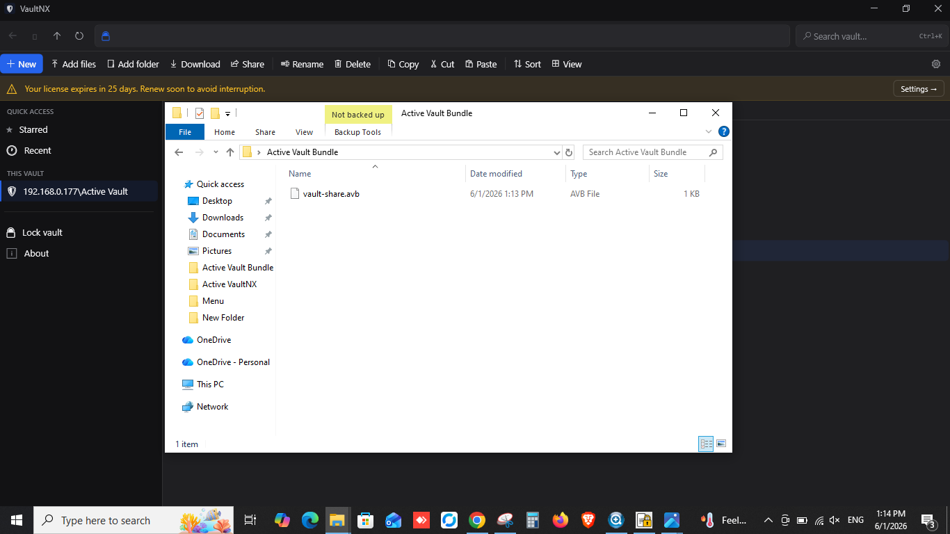
Figure 17 — Saved .avb file in Windows Explorer

5.2 Encrypted ZIP (.zip)
An Encrypted ZIP creates a standard AES-256 encrypted archive. The recipient can open it with 7-Zip, WinRAR, or macOS — Active Vault is not required on their machine.

To export as an Encrypted ZIP:
- Select Encrypted ZIP in the Share Files dialog.
- Enter a password in the ZIP password and Confirm password fields, then click Export…

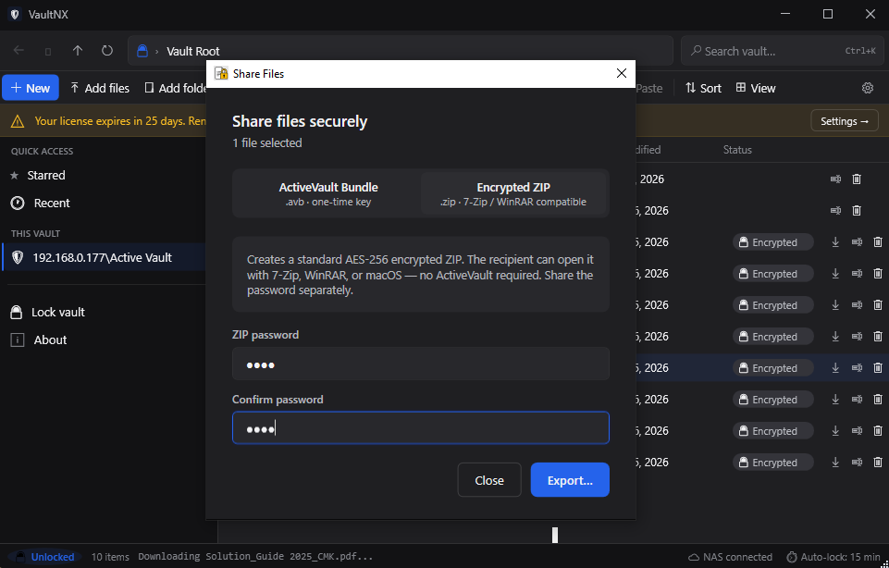
Figure 18 — Setting a ZIP password

On success, “Encrypted ZIP exported successfully.” is shown in green.
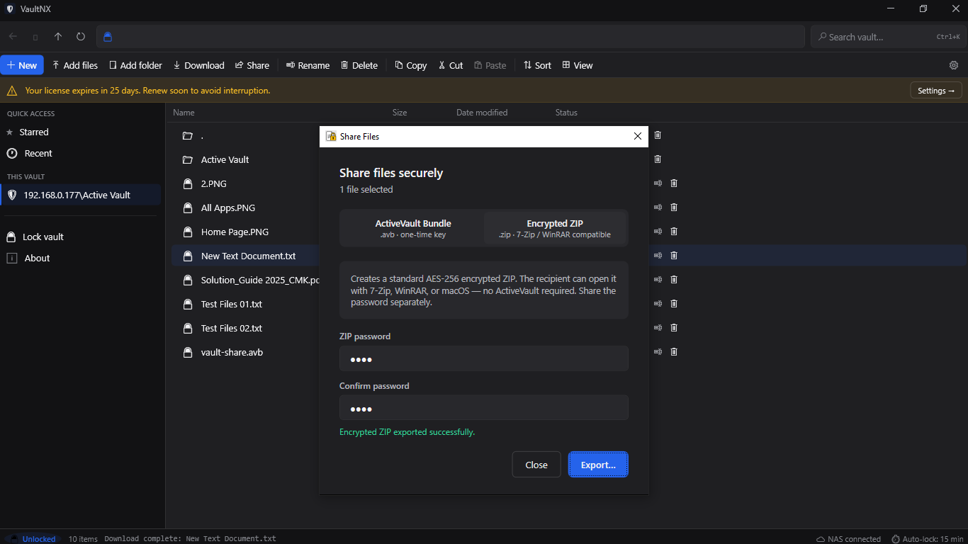
Figure 19 — Encrypted ZIP exported successfully

The saved .zip file appears in Windows Explorer as a standard compressed archive.
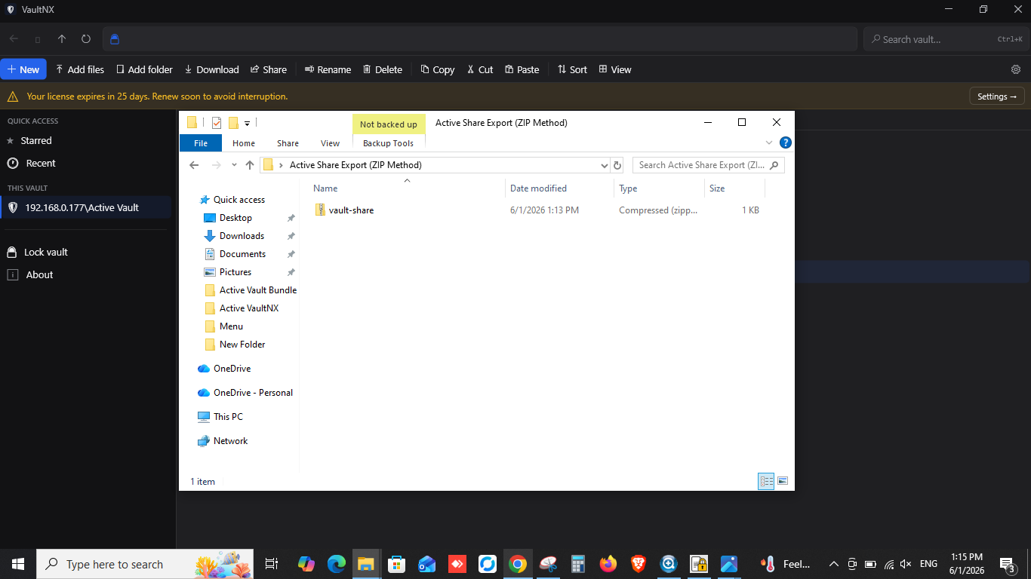
Figure 20 — Saved .zip file in Windows Explorer

ℹ Send the ZIP file and the password through separate channels. Do not include the password in the same email as the file.

6. Settings
Open Settings from the Settings → button in the top-right corner of the vault browser. The Settings window has six tabs: NAS Connection, Security, General, Audit Log, License, and About.

6.1 NAS Connection
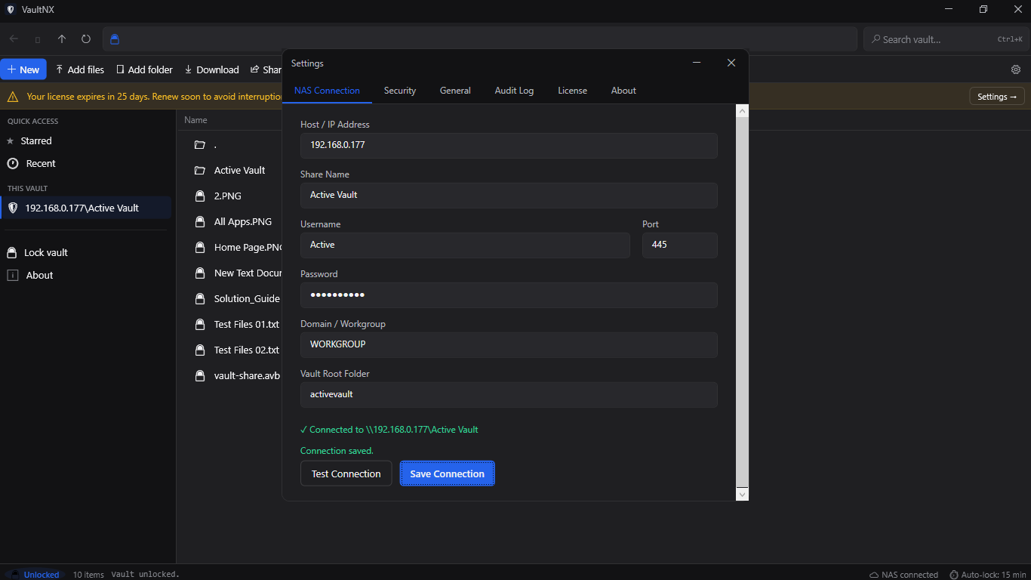
Figure 21 — NAS Connection settings

Field | Description
Host / IP Address | The IP address or hostname of your NAS (e.g. 192.168.0.177)
Share Name | The SMB share that contains your vault (e.g. Active Vault)
Username | The NAS user account with read/write access to the share
Port | SMB port — default 445
Password | The NAS user account password (stored encrypted)
Domain / Workgroup | Leave as WORKGROUP for most home and small-business NAS devices
Vault Root Folder | Subfolder on the share where encrypted data is stored (e.g. activevault)

Click Test Connection to verify settings without saving, then Save Connection to apply. A green “Connected to \\host\share” message confirms a successful connection.

6.2 Security
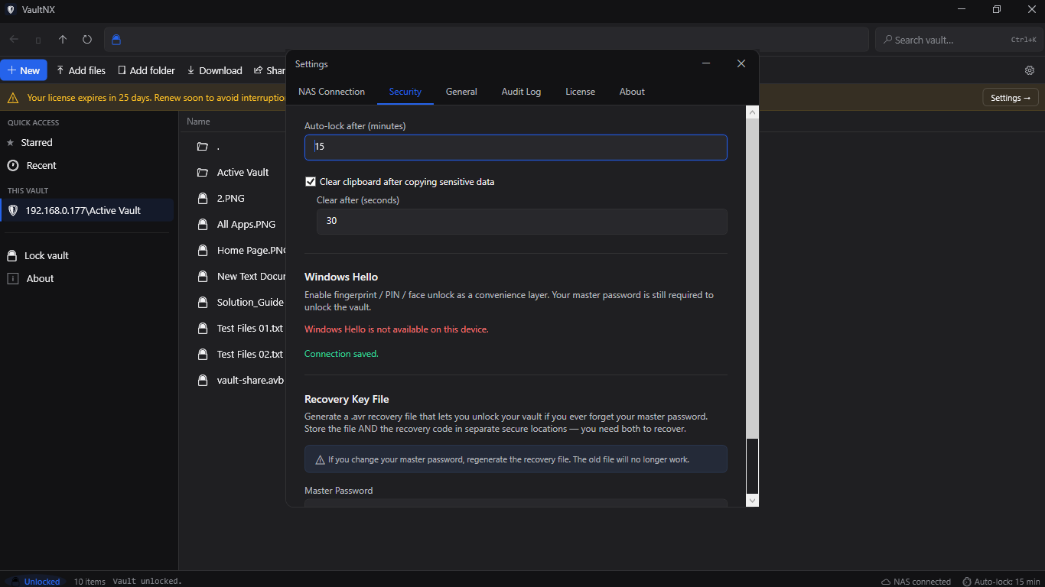
Figure 22 — Security settings

Auto-lock after (minutes): The vault locks automatically after this many minutes of inactivity. Default is 15 minutes.
Clear clipboard after copying sensitive data: When enabled, the clipboard is cleared after the configured number of seconds (default 30).
Windows Hello: Enables fingerprint, PIN, or face unlock as a convenience layer. Your master password remains the underlying encryption key.

Recovery Key File
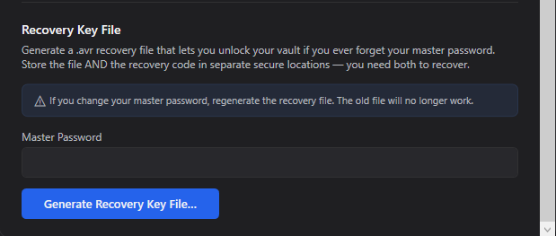
Figure 23 — Recovery Key File section
Generates a .avr file that allows vault access if you forget your master password. Enter your current master password and click Generate Recovery Key File…

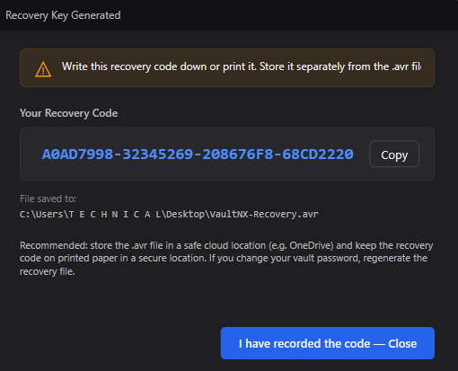
Figure 24 — Recovery code generated

A recovery code is displayed and the .avr file is saved to your chosen location. Click Copy to copy the code, then click I have recorded the code — Close.
⚠ Store the .avr file and recovery code in separate locations. Recommended: .avr file to a cloud location (e.g. OneDrive), recovery code printed and stored securely. If you change your master password, regenerate the recovery file — the old one will not work.

6.3 General
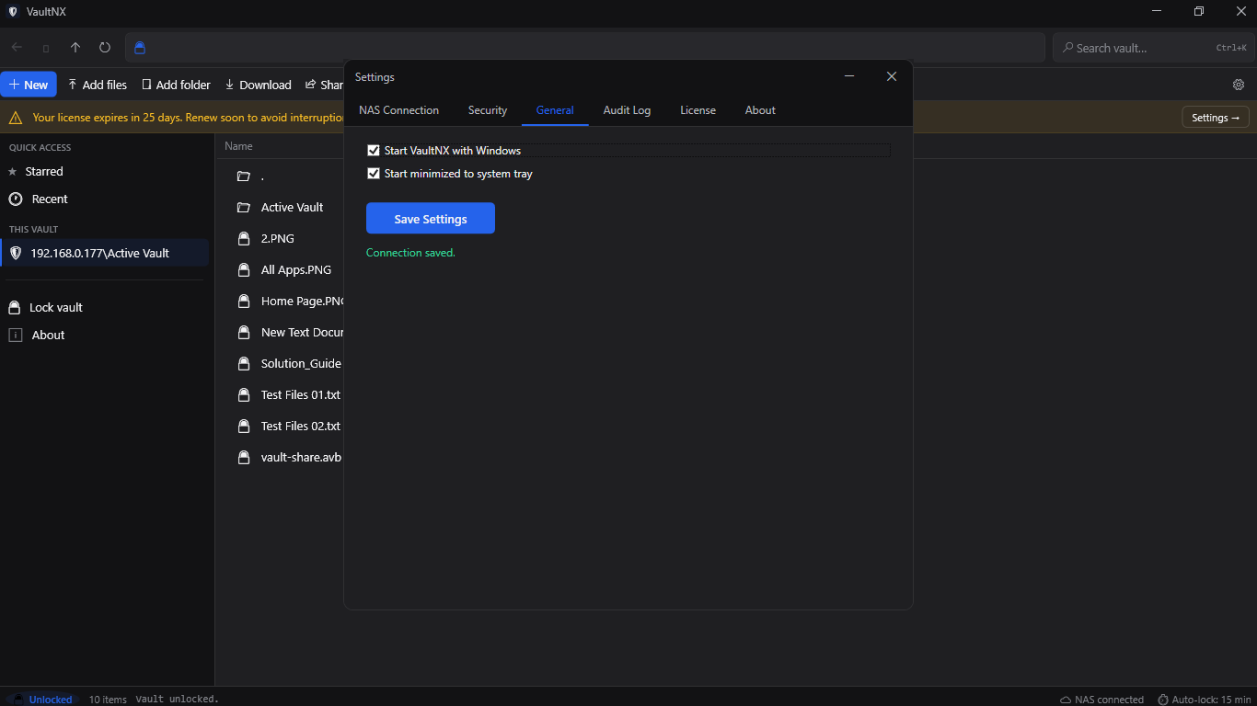
Figure 25 — General settings
Start VaultNX with Windows: When enabled, Active Vault launches automatically at login.
Start minimized to system tray: The app starts in the background without opening the main window.
Click Save Settings to apply changes.

6.4 Audit Log
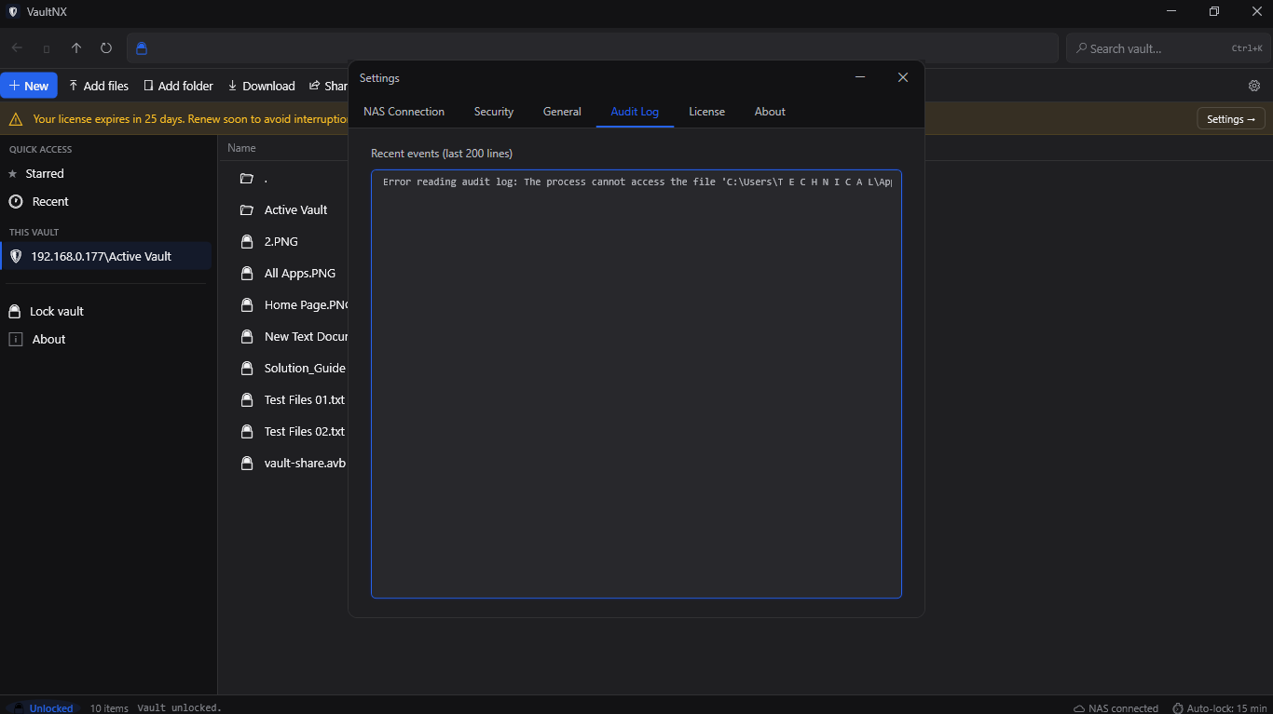
Figure 26 — Audit Log
Displays the last 200 lines of the local audit log — a tamper-evident record of vault activity including unlocks, file operations, and errors. Use this to review access history on the machine.

6.5 License
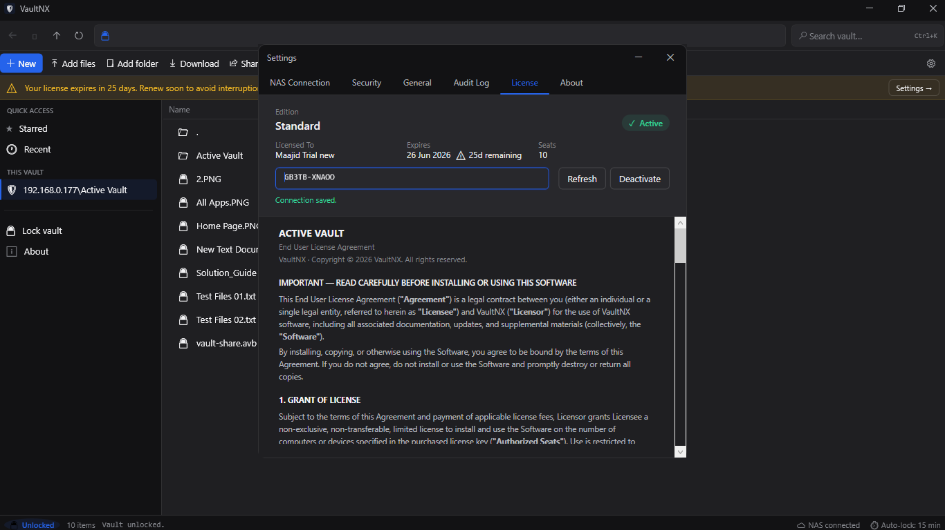
Figure 27 — License information
Shows the currently active license: edition, licensee, expiry date, days remaining, and seat count.
- Refresh — re-validates the license with the server, useful after a renewal.
- Deactivate — releases this machine's seat, allowing activation on a different PC.
The license key field allows entry of a new key if you need to switch licenses.

6.6 About
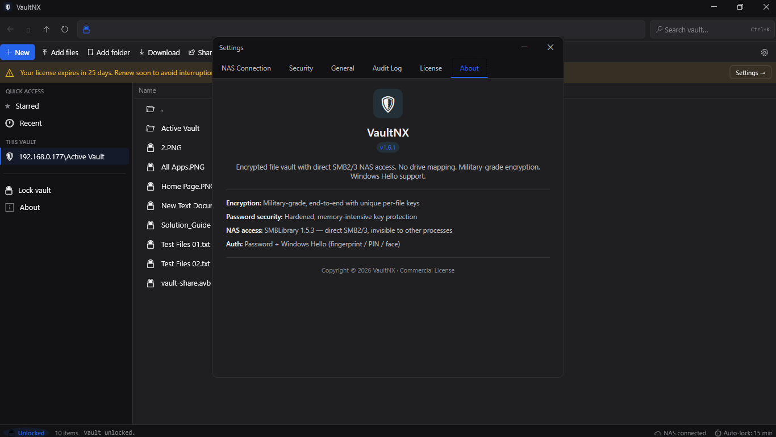
Figure 28 — About screen
Displays the current version and a summary of core technologies: encryption standard, key derivation method, NAS library version, and supported authentication methods.

7. Troubleshooting

7.1 NAS Login Failure (STATUS_LOGON_FAILURE)
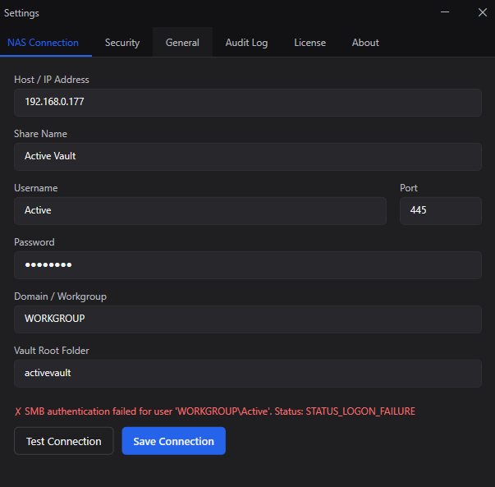
Figure 29 — SMB authentication failure in NAS Connection settings
Error: SMB authentication failed for user 'WORKGROUP\username'. Status: STATUS_LOGON_FAILURE
Steps to resolve:
- Double-check the Username and Password in Settings → NAS Connection.
- Verify the Domain / Workgroup field. Most home NAS devices use WORKGROUP.
- Some NAS devices have a separate SMB user from the admin login — check NAS user management.
- If the NAS password was recently changed, update it here and click Save Connection.

7.2 NAS Unreachable at Vault Unlock
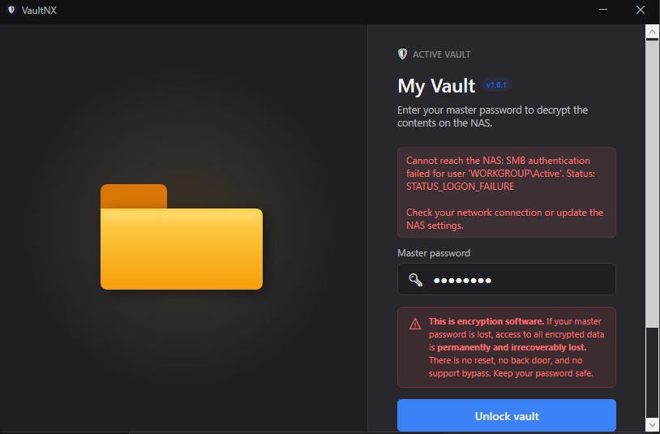
Figure 30 — NAS connection error on the unlock screen
Error: Cannot reach the NAS: SMB authentication failed… STATUS_LOGON_FAILURE — Check your network connection or update the NAS settings.
Steps to resolve:
- Confirm the NAS is powered on and reachable on the network.
- Check that the NAS IP address has not changed. Set a static IP on the NAS, or reserve it in your router's DHCP settings.
- Open Settings → NAS Connection and click Test Connection to diagnose further.

7.3 Forgot Master Password
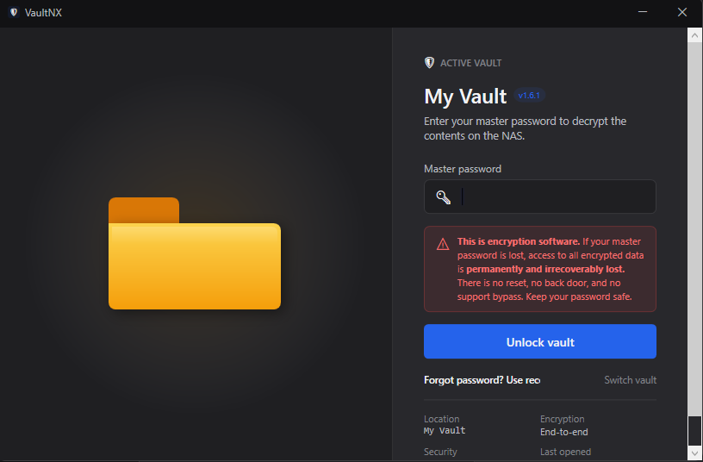
Figure 31 — Unlock screen with Forgot password link
If you forget your master password, click Forgot password? Use recovery on the unlock screen. You will need both the .avr recovery file and the recovery code saved during key generation (see Section 6.2).
⚠ If no recovery key file was generated before losing the password, the encrypted data cannot be recovered. There is no back door or support bypass.

7.4 Share Export Errors
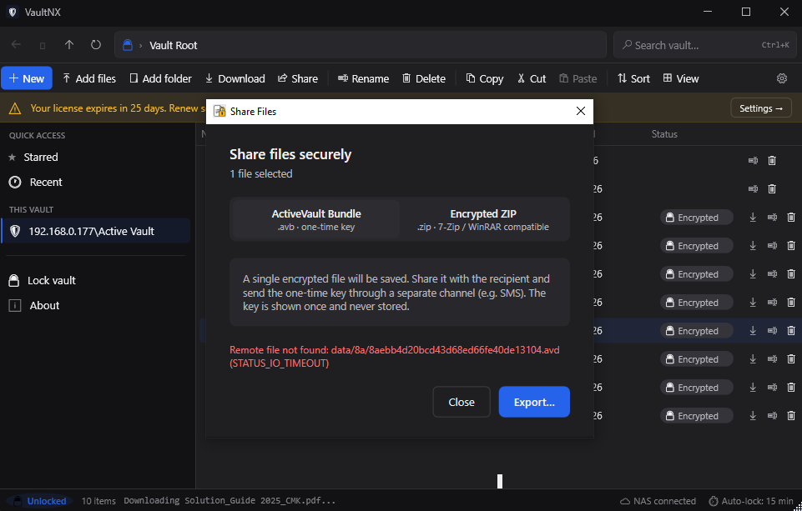
Figure 32 — Share export error (NAS timeout)
STATUS_IO_TIMEOUT: The NAS did not respond in time while reading the source file. Verify the NAS is reachable and retry.
STATUS_INVALID_SMB: The SMB connection was dropped mid-transfer. This can occur during large exports on a slow network. Retry the export.

Active Vault v1.6.1 · Copyright © 2026 VaultNX. All rights reserved.

